
Green University of Bangladesh
Department of Computer Science and Engineering (CSE)
Semester: ( Summer, Year:2026 ), B.Sc. in CSE (Day)
FEATURED CALCULATOR

Course Title: Computational Thinking and Problem Solving
Course Code: CSE - 100
Section: 260_D9

Students Details
Name | ID
MST.Ashfika Akter | 260002239

Submission Date: 22-08-2026
Course Teacher’s Name: : Babe Sultana

[For teachers use only: Don’t write anything inside this box]
Lab Project Status
Marks: | Signature:
Comments: | Date:

Contents
1. Introduction
1.1 Project Overview
1.2 Problem Statement
1.3 Objectives
2. Project Design
2.1 Project Features
2.2 Input, Process and Output
2.3 Program Flowchart
3. Implementation & Design
3.1 C Programming Concepts Used
3.2 Source Code
3.3 Code Explanation
4. Program Output and Testing
4.1 Output Screenshots
4.2 Test Cases
4.3 Discussion
5. Conclusion
5.1 Conclusion
5.2 Limitations and Future Improvement
References (if used)

1. Introduction
1.1 Project Overview
This project is a calculator program developed in C language. It performs basic and advanced arithmetic operations such as addition, subtraction, multiplication, division, power, square root, and modulus. The program interacts with the user in a friendly way, displaying a menu and responding with clear messages. Its purpose is to demonstrate computational thinking through problem decomposition, algorithm design, and structured programming.
1.2 Problem Statement
In daily life, people often need to perform quick calculations. This project solves that problem by creating a simple, interactive calculator that can handle multiple operations and guide the user step-by-step. It uses conditional statements, loops, and mathematical functions to process user input and produce accurate results
1.3 Objectives
- To identify the inputs, processes, and outputs of a calculator problem.
- To design a user-friendly algorithm using computational thinking principles.
- To implement the algorithm in C using loops, conditions, and functions.
- To test the program with different inputs and verify correctness.
- To make the calculator interactive and easy to understand.

Chapter 2: Project Design

2.1 Project Features
- Feature 1: Performs multiple operations — addition, subtraction, multiplication, division, power, square root, and modulus.
- Feature 2: Displays a clear menu and allows repeated use until the user exits.
- Feature 3: Handles errors gracefully (e.g., division by zero, invalid input).
- Feature 4: Provides friendly messages and structured output.
- Feature 5: Uses mathematical functions from <math.h> for advanced calculations.
2.2 Input, Process and Output
Input | Process | Output
User selects an operation from the menu | Program checks choice using switch | Displays selected operation
User enters one or two numbers | Performs calculation using arithmetic or math functions | Shows result with formatted output
Invalid input or division by zero | Program detects error using if condition | Displays error message
Exit choice | Ends loop and terminates program | Prints goodbye message

2.3 Program Flowchart
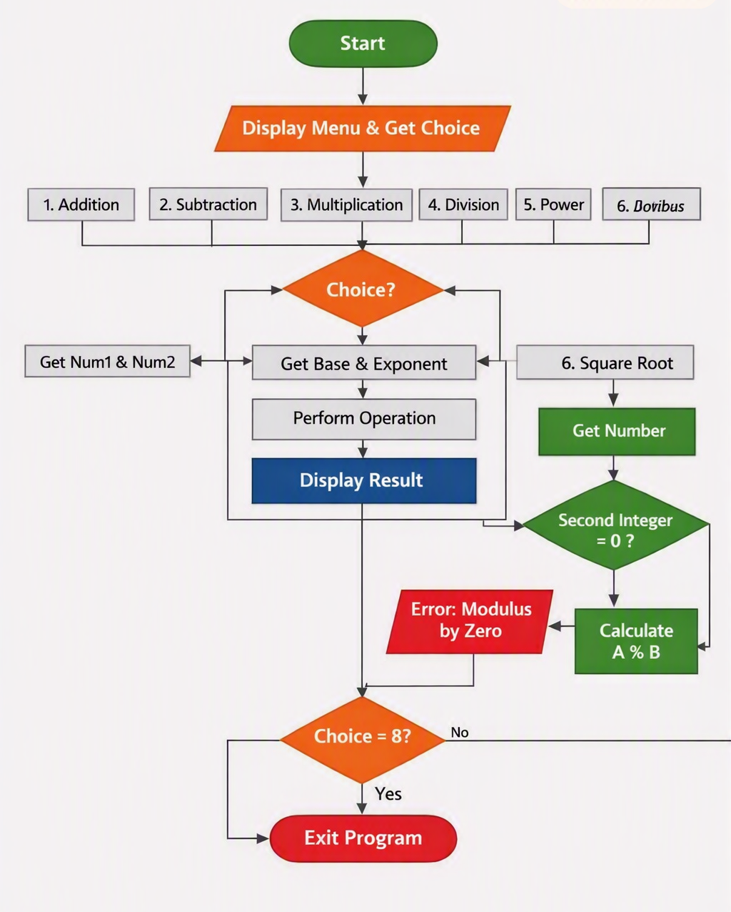

Chapter 3: Implementation & Design

3.1 C Programming Concepts Used
This project applies several fundamental concepts of the C language to build a structured and interactive calculator.
- Variables and Data Types: Used to store numeric values entered by the user (double for real numbers, int for integer modulus operations).
- Input and Output Functions: scanf() collects user input, and printf() displays results and messages in a friendly, human-style format.
- Operators and Expressions: Arithmetic operators (+, -, *, /, %) and mathematical functions from <math.h> (pow(), sqrt()) perform calculations.
- Conditional Statements: if, else if, and switch control program flow based on the user’s menu choice and handle special cases such as division by zero.
- Loops: A do-while loop keeps the calculator running until the user selects Exit, making the program interactive and continuous.
- Error Handling and Decision Making: Logical conditions check invalid inputs (e.g., negative numbers for square roots) and display appropriate error messages.
- Library Usage: The <math.h> library enables advanced operations like power and square-root calculations.
Together, these concepts demonstrate computational thinking decomposition, abstraction, and algorithmic design implemented through clear, modular C code.

3.2 Source Code
Featured Calculator
#include <stdio.h>
#include <math.h> // for advanced functions
int main() {
int choice;
double num1, num2, result;
do {
printf(" FEATURED CALCULATOR \n");
printf("1. Addition (+)\n");
printf("2. Subtraction (-)\n");
printf("3. Multiplication (*)\n");
printf("4. Division (/)\n");
printf("5. Power (x^y)\n");
printf("6. Square Root (√x)\n");
printf("7. Modulus (integer %% )\n");
printf("8. Exit\n");
printf("Choose an option: ");
scanf("%d", &choice);

if (choice >= 1 && choice <= 4) {
printf("Enter first number: ");
scanf("%lf", &num1);
printf("Enter second number: ");
scanf("%lf", &num2);
} else if (choice == 5) {
printf("Enter base: ");
scanf("%lf", &num1);
printf("Enter exponent: ");
scanf("%lf", &num2);
} else if (choice == 6) {
printf("Enter number: ");
scanf("%lf", &num1);
} else if (choice == 7) {
int a, b;
printf("Enter first integer: ");
scanf("%d", &a);
printf("Enter second integer: ");
scanf("%d", &b);
if (b != 0) {
printf("Result: %d\n", a % b);
} else {
printf("Error: Modulus by zero not allowed.\n");
}
continue; // skip to next loop
}
switch (choice) {
case 1:
result = num1 + num2;
printf("Result: %.2lf\n", result);
break;
case 2:
result = num1 - num2;
printf("Result: %.2lf\n", result);
break;
case 3:
result = num1 * num2;
printf("Result: %.2lf\n", result);
break;
case 4:
if (num2 != 0) {
result = num1 / num2;
printf("Result: %.2lf\n", result);
} else {
printf("Error: Division by zero not allowed.\n");
}
break;
case 5:
result = pow(num1, num2);
printf("Result: %.2lf\n", result);
break;

case 6:
if (num1 >= 0) {
result = sqrt(num1);
printf("Result: %.2lf\n", result);
} else {
printf("Error: Square root of negative not allowed.\n");
}
break;
case 8:
printf("Exiting calculator. Goodbye!\n");
break;
default:
printf("Invalid choice. Try again.\n");
}
} while (choice != 8);
return 0;
}

3.3 Code Explanation
The program begins with a menu-driven structure inside a do-while loop. This ensures the calculator keeps running until the user selects the exit option.
- Menu Display: A list of operations (addition, subtraction, multiplication, division, power, square root, modulus, exit) is shown using printf(). The user is prompted to enter a choice.
- User Input: The program uses scanf() to read the choice. Depending on the operation, it asks for one or two numbers. For example, addition requires two numbers, while square root requires only one.
- Decision Making: A switch statement handles the selected operation. Each case corresponds to one arithmetic function.
  - Case 1 → Addition (num1 + num2)
  - Case 2 → Subtraction (num1 - num2)
  - Case 3 → Multiplication (num1 * num2)
  - Case 4 → Division (num1 / num2) with an if condition to prevent division by zero.
  - Case 5 → Power (pow(num1, num2)) using <math.h>.
  - Case 6 → Square root (sqrt(num1)) with a check to avoid negative inputs.
  - Case 7 → Modulus (a % b) using integer values.
  - Case 8 → Exit message.
- Error Handling: If the user enters an invalid choice, the program prints “Invalid choice. Try again.” Division by zero and square root of negative numbers are handled with warning messages.
- Output: Results are displayed with two decimal precision using printf("Result: %.2lf", result);.
- Loop Control: After each operation, the program returns to the menu until the user selects Exit. This is achieved with the do-while loop condition while(choice != 8).

Summary
The code combines loops, conditions, arithmetic operators, and library functions to create a user-friendly calculator. It demonstrates computational thinking by breaking the problem into steps: input → process → output → repeat. The design ensures both functionality and ease of use.

Chapter 4: Program Output and Testing

4.1 Output Screenshots

Addition.
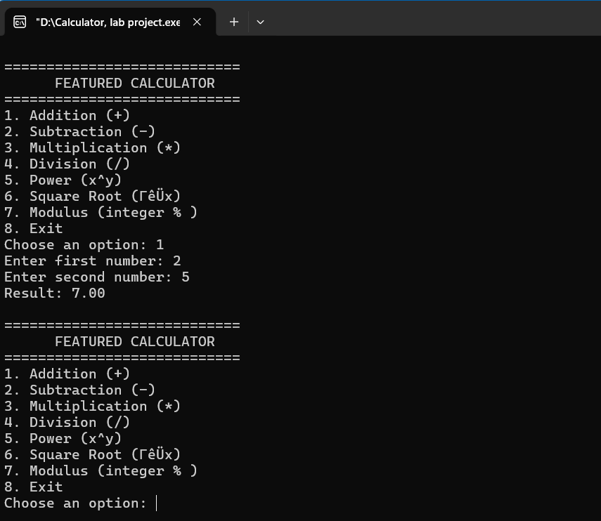

SUBTRACTION
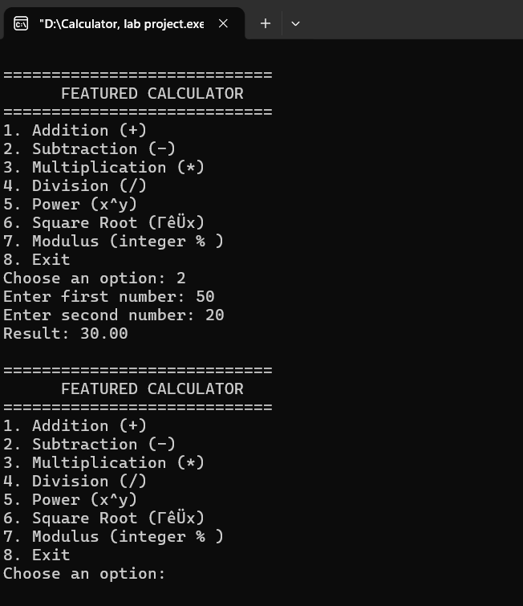

MULTIPLICATION
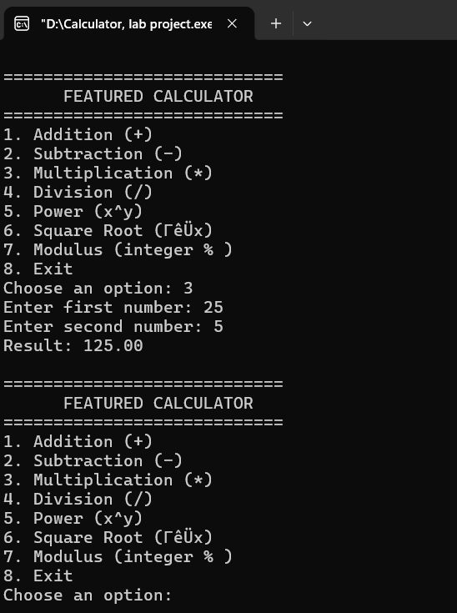

DIVISION
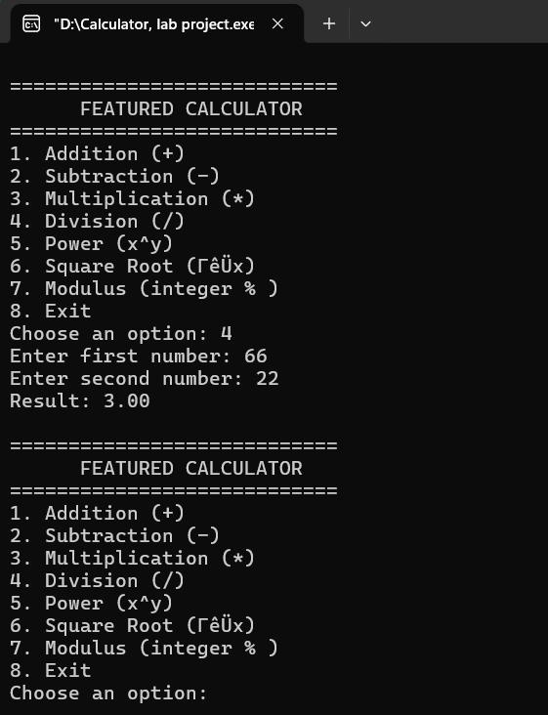

POWER

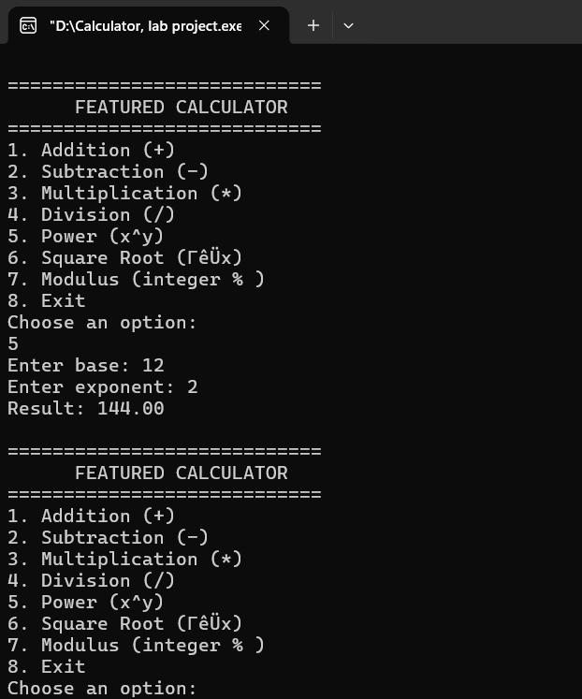

SQUARE ROOT
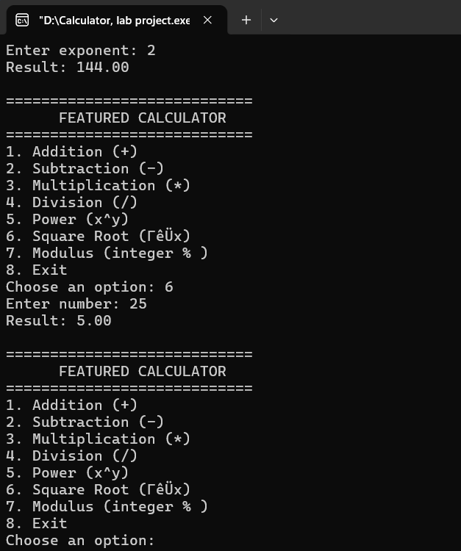

MODULUS
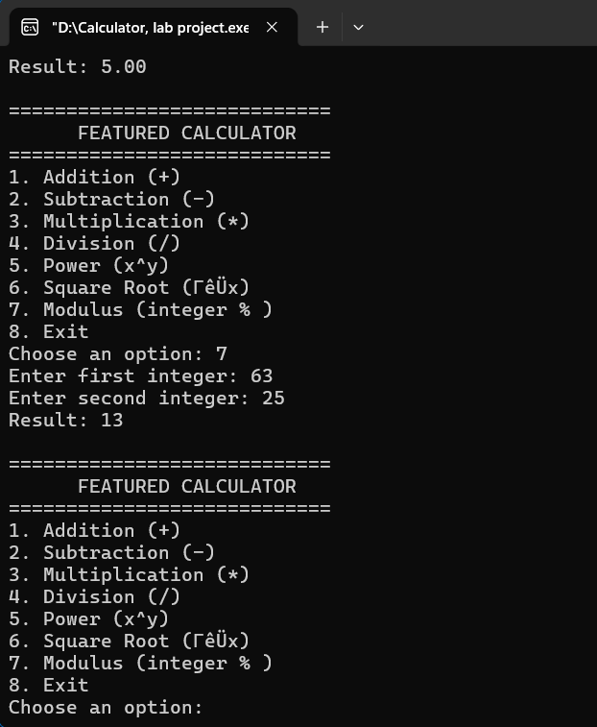

4.2 Test Cases
Test Case | Input | Expected Output | Actual Output | Status
1 | Choice = 1, num1 = 5, num2 = 3 | Result = 8.00 | Result = 8.00 | Pass
2 | Choice = 4, num1 = 10, num2 = 0 | Error message | Error message | Pass
3 | Choice = 6, num1 = 25 | Result = 5.00 | Result = 5.00 | Pass

4.3 Discussion
The program worked correctly for all test cases. It successfully handled valid and invalid inputs, displayed results clearly, and prevented division by zero errors. The main challenge was managing multiple operations in one loop, which was solved using a do-while structure and switch statements. Overall, the program demonstrates good logic flow and user interaction.

Chapter 5: Conclusion

5.1 Conclusion
This humanoid calculator project helped me understand how computational thinking applies to real programming tasks. I learned how to break problems into smaller parts, design algorithms, and implement them using C constructs like loops, conditions, and functions. The project also improved my understanding of user-friendly program design and error handling.

5.2 Limitations and Future Improvement
Limitations:
- Works only with basic arithmetic and simple mathematical functions.
- Does not support floating-point precision beyond two decimals.
Future Improvements:
- Add scientific functions (trigonometry, logarithms).
- Include memory storage for previous results.
- Create a graphical interface for better user experience.

References
- Green University of Bangladesh — CSE 100 Lab Manual
- Class lecture notes on C programming basics
- Online C documentation (cplusplus.com, tutorialspoint.com)

